Woburn Lower School

Prospectus 2024-2025

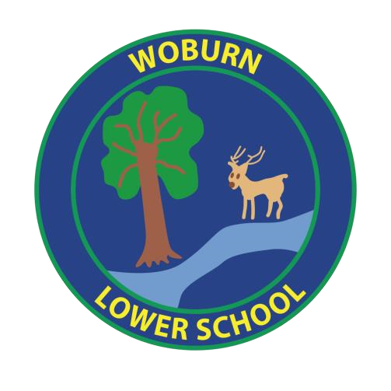

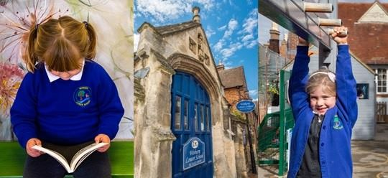

# Contact Details

**Email:** office@woburn-lower-school.co.uk

**Phone:** 01525 290207

**Fax:** 01525 290207

## Website: <https://woburn-lower-school.co.uk/>

**Address** Woburn Lower School

Bedford Street

Woburn

Bedfordshire

MK17 9QL

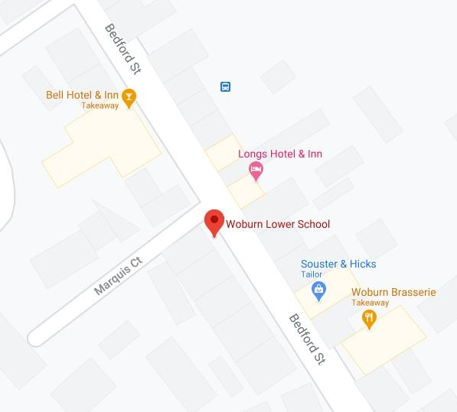

# Contents

Section Page Number

Welcome 4

Our Vision 5

Ofsted Inspection Highlights 6

The Curriculum 7 - 12

What are the Key Stages? 13

Special Educational Needs and Inclusion 14

Staffing 15

Governing Body 15

Admissions 16

Health and Absence 16 - 17

Morning and after school clubs 18

School Hours 18

School Uniform 19

Lunches and Snacks 20

Home School Partnership 21

Friends of Woburn Lower School 21

# Welcome

Dear Parents, Carers and Friends

It is with pleasure that we welcome you to Woburn Lower School.

We consider ourselves a very happy family. Our children are friendly, motivated and extremely well behaved.

Our innovative teachers are talented and dedicated and they are supported by an excellent team of teaching assistants. We have high academic standards and set challenging targets, but see this as only part of the picture. In order for our children to thrive they need to reach their full potential in all areas and to develop confidence, resilience and kindness towards others.

Our small school is set in a Grade 1 listed Tudor building. We promote healthy lifestyles; employing professional sports coaches throughout the week, and taking part in a range of inter-school sporting competitions. All the children contribute to the upkeep of our school allotment. They are excited and proud to sample the vegetables that we grow there and enjoy taking part in annual gardening competitions.

We encourage parents and carers to become a part of our school family and to fully engage in their children’s learning.

We hope that you like our website and that it gives you all the information you need. Please do not hesitate to contact Emma or Caroline, our Office Managers, if you would like to know more.

We think Woburn Lower School is a very special place.

Paula Black

Headteacher

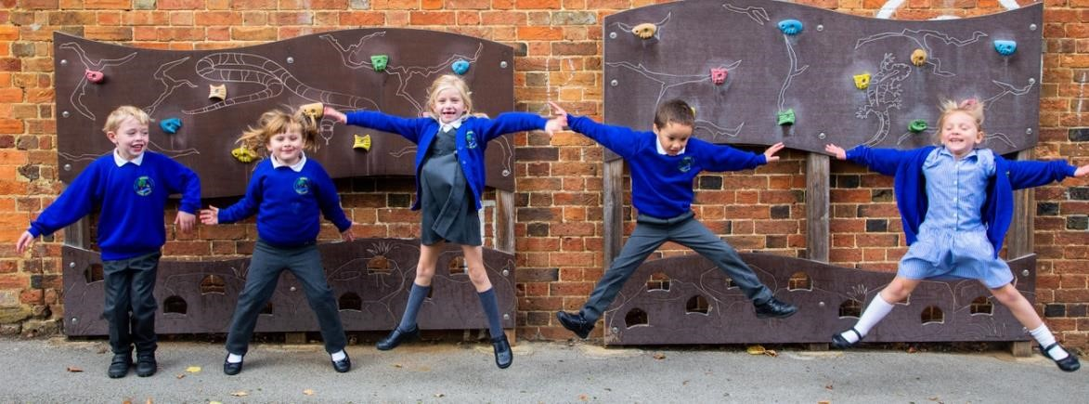

# Our Vision Statement

Our school vision statement is ‘Aspire to inspire’

We aim to inspire the children at Woburn Lower School to be happy, confident and proud of themselves, showing respect, tolerance and empathy towards others. Through inspiring teaching and providing an exciting, broad and balanced curriculum and a stimulating environment, we strive to develop positive attitudes to learning; encouraging children to embrace challenge and work towards the next steps in their learning. We have high expectations of pupil achievement, helping each child to reach their full potential wherever their interests and talents lead them. We aim to build resilient learners who think logically and systematically. With wellbeing always at the centre of what we do, we provide a safe and nurturing environment.

**Ofsted Inspection Highlights**

Our last Ofsted inspection was in 2023. We were graded as ‘Good’ in ‘Quality of Education’, ‘Leadership and Management’ and ‘Early Years’ with the two areas of ‘Behaviour and Attitudes’ and ‘Personal Development’ graded as ‘Outstanding’. Here are some of the highlights of the report. The full report can be read on our website.

**Ofsted - ‘What is it like to attend this school?’**

* Pupils believe Woburn Lower School is a special place. They are immensely proud to be part of a learning community that has occupied the school’s historic buildings for over 400 years.
* Pupils’ enthusiasm for learning permeates the school. Their positive attitudes, along with adults’ high expectations, result in most pupils achieving very well.
* Pupils regard the school’s small size as a strength. They love the way everyone gets to know each other well. This includes the adults. The strong bonds that are formed between adults and pupils mean that pupils feel safe and happy at school.
* Adults model the behaviour they expect from pupils. They establish clear routines and high expectations from the moment children join the Reception class. These set the foundations for excellent behaviour as pupils move through the school.
* The range of opportunities for pupils to contribute to the school community and develop their character is impressive. Roles such as house captains, ambassadors and school councillors enable pupils to develop leadership skills and responsibility from an early age.
* The school’s curriculum is broad and ambitious. It is carefully designed to meet the needs of pupils in the mixed-age classes. The curriculum sets out a logical sequence for the teaching, so that pupils build up deep and detailed knowledge over time. Overall, pupils achieve well, particularly in English and Mathematics.
* Reading is at the heart of the curriculum. Pupils read widely and often. They listen attentively to the stories adults share with them. Early reading is taught effectively through daily phonics lessons. These start as soon as children join the Reception class. Teachers identify any pupils who need extra help early. Pupils get tailored support so that they can progress. Consequently, most pupils quickly become competent and keen readers.
* Pupils behave extremely well in lessons and around the school. Their classrooms are calm spaces where learning is not disrupted.

Our Curriculum

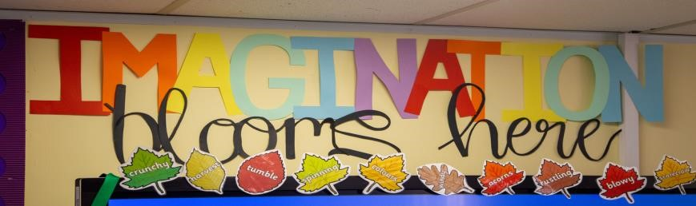

At Woburn Lower School our broad and balanced curriculum meets the National Curriculum requirements for all subjects whilst building upon the experience and interests of our pupils. We believe that all children should have the opportunity to feel motivated and excited about learning and to experience the feeling of accomplishment in a wide range of areas. Our curriculum gives children an excellent mix of academic and personal development. Spiritual, moral, social and cultural development underpins all our work.

Our topics focus on familiar subjects such as ‘Space’ and the ‘Romans’ as well as a range of ‘In the moment’ topics such as ‘Shakespeare for Kids’ which was a joint project with a local upper school. For ‘The Young Curator’s Project’, the children worked with the curator at Woburn Abbey, where they learnt to become curators and to show families around this magnificent stately home. The children have set up companies for their ‘Dragon’s Den’ and ‘Young Apprentice’ projects and called upon financial advice from banks and local businesses. Great effort is made to support pupils growing depth of understanding and interest.

We aim for our children to be inspired and to enjoy their learning - developing enquiring minds alongside the personal qualities they need to be positive citizens of the world.

Early Years – Owls Reception Class

In Reception class we follow the Foundation Stage curriculum which continues the learning journey from nursery and playgroup.

The seven areas of learning within the Foundation Stage incorporate:

The Prime Areas:

* Communication and language
* Physical development

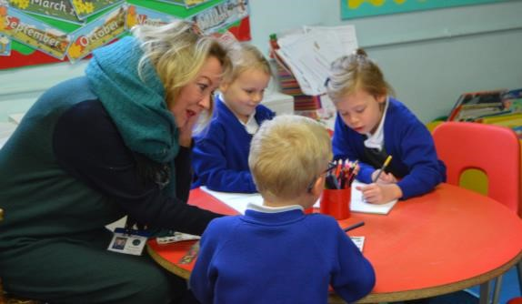

* Personal, social and emotional development The Specific Areas:
* Literacy
* Mathematics
* Understanding the world
* Expressive Arts and Design

Our provision is happy and stimulating, encouraging children to be enthusiastic, independent learners within a positive and well-resourced learning environment. Alongside our indoor classroom area, we are fortunate to have our own outdoor classroom and little garden which the children access throughout the day. Learning is delivered through adult led and child initiated activities and enhanced through planned purposeful play, exploration and investigation of the world around us. Play is essential for children’s development, building their confidence as they learn to explore, to think about problems, and to communicate and socialise with others. Children learn by leading their own play, and by taking part in play which is guided by adults. Topics are planned half termly and are influenced by the Hygge philosophy alongside the children’s own interests and fascinations. It is an integrated curriculum that supports and encourages the children to practise and refine early writing, literacy and number skills. We follow a daily ‘TWINKL’ phonics programme using a range of motivating and imaginative approaches and resources.

Parents and carers are encouraged to join in with our learning through attending our very popular ‘Curriculum Mornings’. They are also very welcome to come and help in class, hearing readers or supporting group activities.

Reception is very much a part of the whole school and the children take part in whole school assemblies, whole school trips and social events. Our Reception children are also included in the weekly specialist teaching of French on Tuesday afternoons.

The Early Years staff liaise very closely with Year 1 to promote a smooth transition between the key stages and to help children prepare for the more formal learning in Year 1.

We believe that through supporting children’s emerging needs and interests, guiding their development through warm, positive and effective interactions, they will grow into successful, sociable, happy children with positive self- esteem.

## Squirrels KS1 Class and Badgers KS2 Class

### Mathematics

At Woburn Lower School mathematics is carefully planned throughout the school to ensure continuity and progress. We place a great emphasis on children demonstrating conceptual understanding and fluency through problem-solving and reasoning activities, linking mathematics to real life situations and making cross-curricular links. Metacognitive approaches such as scaffolding, modelling and teachers verbalising their thinking are used throughout the school in order to give all children the ability to apply their learning.

Teachers set work that is challenging, motivating and engaging. Children work in a number of different ways including as a whole class, small group and independently. Provision for children who may have special needs or just have need for additional support is made through differentiation of tasks and resources and adult support.

Marking of pupil work is developmental and used to move children’s learning on at all times. Misconceptions are quickly picked up and time is given for children to respond to marking and to consider their own learning, achievements and next steps. Regular formative assessments are shared with the headteacher in order to monitor progress.

### Reading

At Woburn Lower School we celebrate and encourage reading, teaching skills and knowledge to allow our children to become proficient and enthusiastic readers.

Our children enjoy individual and guided reading within the classroom and we encourage parents to become involved with their child’s reading at home. We offer the children a range of fiction and non-fiction books within our reading schemes and our library.

Phonics are taught from the early years and we are proud to say that our school has been in the top 3% of schools for over five years with regard to our phonics results; receiving a congratulatory letter from the Ministry of State for School Standards for consistently achieving a 100% pass rate.

### Writing

At Woburn Lower School we have embraced the use of Talk4Writing throughout the school. Based on the principles of how children learn, Talk4Writing is powerful because it enables children to imitate the language they need for a particular genre/topic orally before reading and analysing it and then writing their own version.

The children write every day and every effort is made for them to write for an audience and for a variety of purposes.

The children are encouraged to develop as independent and accurate spellers who are confident to use an evolving and adventurous vocabulary in their writing.

The formation of letters and the production of neat work is encouraged from the early years and culminates in ‘pen passes’ in Years 3 and 4 as children reach the desired standard.

Science

At Woburn Lower School our high quality science education provides the foundations for understanding the world. Science has changed our lives and is vital to the world’s future prosperity, and all pupils at our school are taught essential aspects of the knowledge, methods, processes and uses of science. Through building up a body of key foundational knowledge and concepts, children will be encouraged to recognise the power of rational explanation and develop a sense of excitement and curiosity about natural phenomena. They are encouraged to understand how science can be used to explain what is occurring, predict how things will behave, and analyse causes. Through careful planning, the teachers ensure that the children are constantly building upon previous knowledge and understanding, making links and working at greater depth learning.

### Religious Education

At Woburn Lower School we use the Religious Education Agreed Syllabus 2023-2028, ‘Identities, meanings, values’.

The principle aim of Religious Education is to explore what people believe and what difference this makes to how they live. Children learn about religions and beliefs in local, national and global contexts, developing their own beliefs and opinions and learning to express them with tolerance and respect for others.

An act of Collective Worship and contemplation takes part every day and is an important part of school life, making time for pupils and staff to come together and share in worship through learning, music and reflection.

History

At Woburn Lower School, the delivery of a creative history curriculum encourages children to understand their place in the world and how past events have influenced our lives today. The curriculum aims to provide children with a chronologically secure knowledge and understanding of British and World history. In addition, children will learn about significant historical events in their local area and compare these to the wider world.

Children are encouraged to ask perceptive questions and to develop skills of enquiry, analysis, interpretation and problem-solving. The past comes to life through the delivery of a broad and balanced curriculum which is creative, engaging and, where possible, cross-curricular. Our unique Tudor building and links with the Heritage Centre and Woburn Abbey help to bring history alive for our children.

### Geography

Through their work in Geography, children learn about their local area and compare this with other regions of the United Kingdom and the rest of the world.

There is a focus on locational and place knowledge as well as developing geographical skills such as using maps, atlases and globes. Through their growing knowledge and understanding of human geography, children gain an appreciation of life in other cultures. In addition, children will study a variety of physical features using subject specific vocabulary.

Children will collect and analyse data from a range of sources and communicate this in a variety of ways, including maps, numbers and writing. Where possible, the study of this subject is cross-curricular and children are provided with an understanding of what it means to be a global citizen, encouraging a respect for other cultures and the environment.

### Music

Music is a universal language that embodies one of the highest forms of creativity. Our high-quality music education engages and inspires pupils to develop a love of music and to explore their talent as musicians, through singing and through using musical instruments. As pupils progress, they learn to develop a critical engagement with music, allowing them to compose, and to listen to music with discrimination. Engagement with Central Bedfordshire ‘Inspiring music’ further enhances our curriculum delivery for music.

### PSHE and wellbeing

At Woburn Lower School social and emotional development is an essential part of everything that we do. During specific teaching time, we use the Jigsaw mindful approach to PSHE, which is an integrated scheme of learning with particular emphasis on emotional literacy, mental health, SMSC and spiritual development. We also use an ‘in the moment’ approach, ready to react to current concerns or issues.

A newly developed pastoral and well-being area, led by our Pastoral Lead Teacher, enables us to provide extra support for those children who may need it.

### Design and Technology

Design and Technology encourages children to think creatively and solve practical problems. Through the process of research, planning, making and evaluating, children apply their learning to solving meaningful real-world tasks. Practical skills such as creating structures and mechanisms, choosing and using appropriate tools and materials, adding electronic components to models, and safe and healthy cooking techniques, are all linked to class topics or situations the children experience. Design and Technology provides many opportunities for using skills learned in maths and literacy lessons, as children need to be able to communicate their ideas and plans effectively and be accurate when preparing materials and ingredients for their projects.

### Art and Design

At Woburn Lower School teachers use a variety of teaching and learning styles in art and design lessons, with our principal aim being to develop the children’s knowledge, skills and understanding. We ensure that children have the opportunity to investigate, explore and develop ideas as well as evaluate, revisit and improve their work. We teach according to topics and the children’s interests, therefore the artists studied may vary.

### Modern Foreign Languages

At Woburn Lower School we believe the earlier a child learns a Modern Foreign Language the better, so we have a native speaking French teacher who teaches from the Early Years to Year 4.

Our high quality French tuition provides an opening to the French culture as well as enabling the children to express themselves and to understand the French language in speech and in writing.

What are the Key Stages?

The National Curriculum is divided into four Key Stages that children are taken through during their school life. For example, Key Stage 1 is taught during Years 1 and 2 of primary school. Targets defined in the National Curriculum are assessed at the end of each Key Stage.

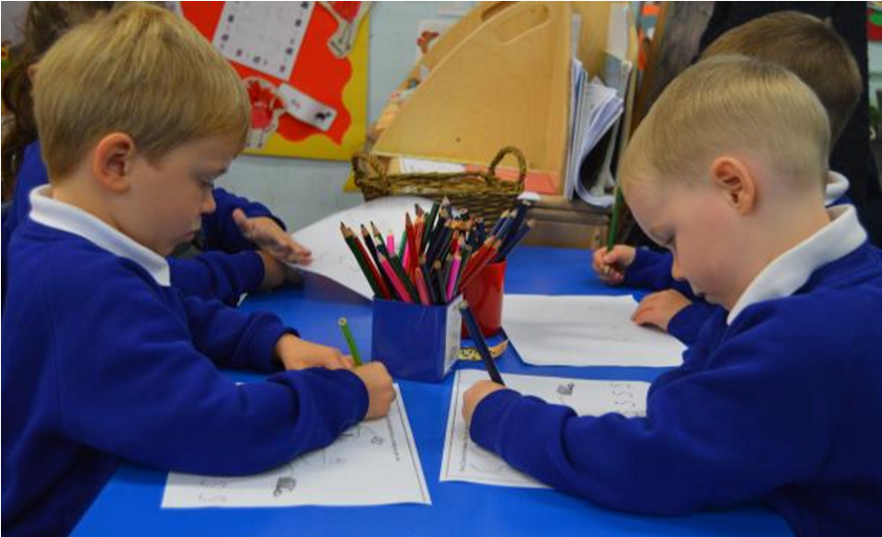

Our Key Stages:

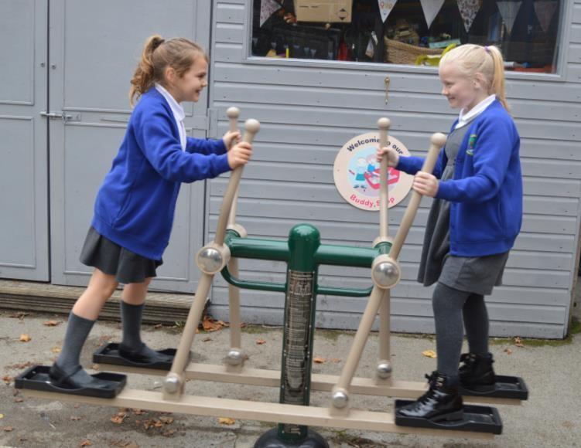

|  |  |  |
| --- | --- | --- |
| **Key Stage 1** | Ages 5-7 | Years 1 and 2 |
| **Key Stage 2** | Ages 7-11 | Years 3 and 4 |

At Woburn Lower School we provide an exciting, motivating and challenging curriculum. Many subjects will be taught through a cross-curricular approach and through topics or themes to make it more meaningful for the children.

Various extra-curricular activities are provided during lunchtimes and after school in order to enhance the children’s learning and offer new experiences. Staff at Woburn plan half-termly and termly topics, the details of which are posted on our website.

# Special Educational Needs and Inclusion

As a school we intend to meet the needs of all our children. Our school ethos encourages a feeling of mutual respect for one another; ensuring we understand children’s individual needs is a natural extension of this.

Some of our pupils may have an outstanding general ability or may have an outstanding ability in specific areas. We encourage our children to set their own individual targets with support and to ‘aim high’. Many of our children are working at greater depth in a variety of subjects.

At the end of each term, a whole school register of children's attainment is drawn up. A range of information is used to draw up this register including testing, teacher assessment and the assessment of pupils' work in line with government standards. This information is used to ensure that we are meeting the needs of all of our children.

Work is differentiated according to need and in order to support each child to achieve their full potential. Should children require additional support,

appropriate ‘intervention’ is then planned. This is also true for children who may find the social aspects of school life a challenge.

Our school SENDco works closely with children, class teachers, parents and outside agencies where necessary to ensure that any specific needs are identified and met.

We promote the idea of ‘Pupil Voice’ through our School Council and Eco Council.

**Staffing**

|  |  |
| --- | --- |
| Mrs Paula Black | Headteacher |
| Mrs Emma Lunn/Ms Caroline McBride | Office Manager/Finance Manager |
| Miss Amy Freeman | Key Stage 1 Leader/Pastoral lead |
| Mrs Kirsty Windle | Early Years Leader |
| Mrs Katrina Grant | Senior Teacher/SENDCo/KS2 Leader |
| Ms Charlie Fields | 1:1 Teaching Assistant |
| Ms Michelle Billington | 1:1 Teaching Assistant |
| Miss Anneliese Evans | 1:1 Teaching Assistant |
| Miss Emily Taylor | Teaching Assistant |
| Miss Kirsty Borthwick | Teaching Assistant |
| Mrs Ria Gordon | Teaching Assistant |
| Mr Peter Gendall | Site Agent |
| Miss Lisa Smith | Mid-day Supervisor |
| Mme Gylphé | French teacher (EYFS - Year 4) |

We also have a peripatetic music teacher who teaches guitar on an individual basis and trained sports coaches who lead active playtimes and PE and Sport lessons.

# Governing Body

|  |  |
| --- | --- |
| Mrs Paula Black | Headteacher |
| Mrs Suzanne Stretton | Chair of Governors/Co-opted Governor |
| Ms Sue Michaels | Vice Chair/Co-opted Governor |
| Mrs Kirsty Windle | Staff Governor |
| Miss Sharon Longmuir | LA Governor |
| Ms Lianne Walton | Parent Governor |

M

r

Jo Wassell

Parent Governor

Mrs Kelly Burley

Clerk to Governors

# Admissions

Information about admissions can be found on the local authority website. School visits are positively encouraged. Please contact the school office to make arrangements.

# Health and Absence

## Absence due to illness

If your child is ill and is going to be absent from school then we ask you to let us know as soon as possible on the first day of absence.

Ways of letting us know:

* A telephone call to the school office on 01525 290207
* Send a note in with a sibling if your child has one at school
* Send an email to the school office at office@woburn-lower-school.co.uk

If your child is absent for more than one consecutive day then we will assume it is for the same reason. Please ensure that on your child’s return to school you send a written note to explain the absence for our records.

If your child has a medical appointment and you will need to collect them during the school day or bring them late to school then please send a written note to keep us informed.

## Request for holiday

Permission for absence from school will only be given in exceptional circumstances. If you wish to request any period of absence please enquire at the school office.

## Penalty notices for unauthorised absence

You could be issued with a penalty notice if your child is absent from school without permission. Penalty notices can be issued by:

* local councils
* headteachers (including deputy and assistant heads authorised by them)

- the police

This can include parents who take their children on holiday during term time without getting authorisation from the school. Please see the Attendance Policy for more details.

## Collecting Children from School

If your child is going to be collected by someone other than yourselves then please ensure that you send a written note or email to inform us of this. If it is a last-minute arrangement due to unforeseen circumstances then please telephone the school on 01525 290207 and leave a message with the School Office as well as sending an email to office@woburn-lower-school.co.uk.

If you are collecting your child but have been delayed then please also inform us with a telephone call to let us know and so that your child does not panic. It can be quite distressing for children if their parent does not arrive to collect them and we do not know why.

## Changes at Home

If there are any changes to circumstances at home which may affect your child then please let us know so that we can keep an eye on them. Of course, any information of this nature will be treated sensitively and in confidence.

## Medical Conditions

Please keep the school informed of any medical conditions both permanent and temporary. If your child develops a new condition (for example asthma, allergies, etc.) then you will need to fill in a new medical conditions form. Please ask for a copy from the school office.

If your child requires medication to be taken at school (for example antibiotics following an illness) then a medication form will need to be completed, please ask at the school office.

Any medication needs to be prescribed by a doctor and have your child’s name clearly printed on it. We also ask that medication be brought directly to the office manager by a parent and not sent in your child’s book bag. This is an important safety measure. Administering medication in school is at the discretion of the head teacher and as such, you may be asked to come into school to give the medication to your child if it is not felt appropriate for staff to do so.

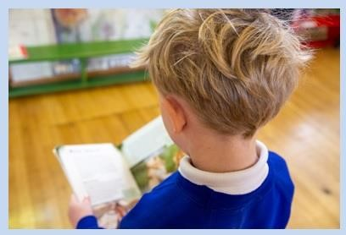

# Kidz Zone morning and after school clubs

Kidz zone run a morning and after school club five days a week at the school. The breakfast club runs from 8am- 9am and includes breakfast. The after school club runs from 3.30pm to 4:45pm. More information can be found on the school website.

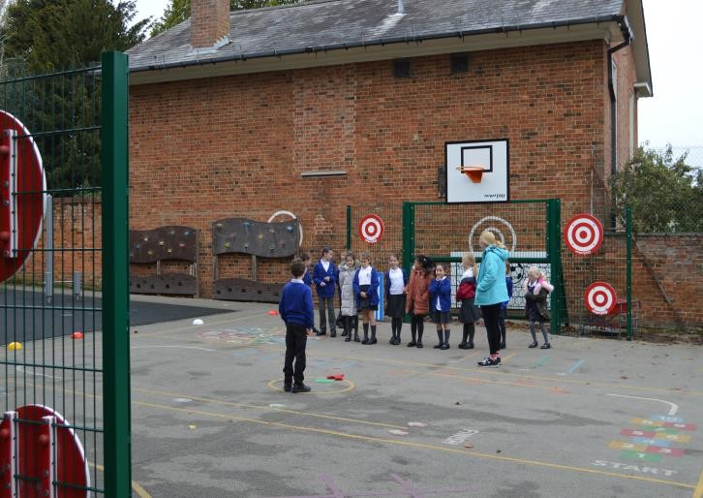

# School Hours

## Timings of the School Day

8:50am – Children line up on the playground

8:55am – Registration

9:00am – Lesson Time

10:15am – Assembly

10:30am – Playtime

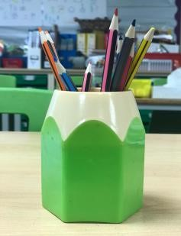

10:45am – Lesson Time

12:00pm – Lunch Time

1:00pm – Afternoon Registration

1:15pm – Lesson Time

There is a short afternoon break but times may vary.

3:30pm – End of School

# School Uniform

All school uniform can be purchased from the Wear 2 School shop in Leighton Buzzard.

The address is:

63 North Street

Leighton Buzzard

LU7 1EQ

You can also order school uniform online directly from their website www.wear2school.co.uk . Please note that uniform will be in stock with them from the last week in August.

Please be aware that the school now holds no stock of new school uniform so all orders must be placed with Wear 2 School. The school does have second hand items of uniform.

**PLEASE ENSURE THAT ALL ITEMS OF CLOTHING ARE CLEARLY NAMED.**

## Girls uniform

Royal blue jumper/cardigan with school logo

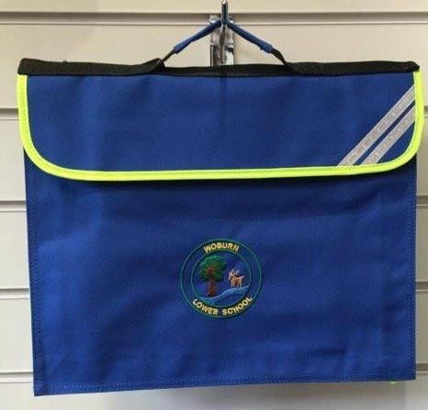White polo shirt with school logo

Grey skirt or pinafore

Blue gingham dress during summer months

White socks

Sensible and supportive black shoes

## Boys uniform

Royal blue jumper with school logo

White polo shirt with school logo

Grey trousers or shorts during summer months

Grey or black socks

Sensible and supportive black shoes

## P.E. Kit

White t-shirt plain or with school logo

Royal blue shorts

Royal blue jogging bottoms (an additional pair would be useful to wear on swimming days)

Plimsolls

Alternative socks are advised for P.E.

A suitable swimming costume and towel will also be required for Year 4

## Extras

Royal blue book bag with school logo

Royal blue drawstring P.E. bag with school logo

School fleece for outside use

# Lunches and Snacks

## School Dinners

School dinners are provided by Hobbs and menus are available on the website.

School dinners are free for children in Reception to Year 2. They are then charged at £2.60 a day. Payment is online and details on how to pay will be given to all new parents.

## Packed Lunches

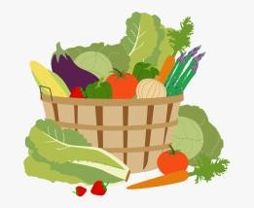If you wish your child to have a packed lunch then it should be brought into school in a suitable container which is clearly labelled with your child’s name. This is especially important as children often have the same lunch boxes and to avoid problems with allergies we need to ensure your child eats the correct lunch!

We do ask that parents try to provide a healthy and balanced packed lunch for their child and that they do not send in cans or fizzy drink, sweets or chocolates. It can be difficult to encourage children to eat a variety of healthy foods at lunch time, so the School Council will be organising a Healthy Lunchbox initiative.

**We have a strict ‘no nuts’ policy.**

## Government Fruit & Vegetable Scheme

As part of the Government scheme, every child in Early Years, Reception and Key Stage 1 (Years 1 & 2) is entitled to a free piece of fruit or vegetable each day. If your child is in Key Stage 2 and is not entitled to the free fruit or they do not like many fruits then please feel free to provide a snack from home for them to eat at playtime. However, please do remember that it needs to be a fruit or vegetable – children will not be permitted to eat any other foods at playtime.

## Milk

All children who are under 5 are entitled to a free carton of milk each day. The children in Early Years drink their milk and eat their fruit together daily at snack time and it is an excellent time for developing independence and social skills.

Once children reach the age of 5 they may continue to have milk if parents are prepared to pay. School milk is provided by Cool Milk. Parents can either register online at www.coolmilk.com or ask for an application form from the school office.

Please ensure that you send your child to school with a named water bottle every day.

# Home-School Partnership

At Woburn Lower School we believe that your involvement in your child’s learning is extremely important and we will do our best to help you to support your child during their time at school. We hold regular ‘Curriculum Mornings’ in Early Years so that parents join in with the teaching and learning in the setting. We have regular exhibitions of work when parents and family can see the children’s wonderful work.

Furthermore we have a variety of ways of sharing information and working closely in partnership:

* We operate an ‘open door’ policy. You are welcome to speak to your child’s class teacher before or after school. For more lengthy discussions please make an appointment to avoid disruption to the school day.
* Newsletters and letters are emailed home regularly, notifying you of events and dates for the diary. These are also posted on our website.
* Curriculum plans are on the website.
* You will be invited to a consultation evening during the first term to see how your child is settling in to his/her new class. There are two further consultation evenings during the school year, one in the Spring term with your child and one in the Summer term if desired. If it is more convenient to have a telephone consultation then this is available.
* You will receive two written reports for your child, which comment on all areas of your child’s development and offers suggestions as to how you can support your child’s learning at home.
* The school’s website is regularly updated with information.
* Parent Forum meetings are held every term.
* The school uses Class Dojo to send photos and homework to parents.

**Friends of Woburn Lower School**

Friends of Woburn Lower School are a group of parents and carers who work enthusiastically to organise both social and fundraising events for the school within the local community. Funds raised are used to pay for various improvements to the school, trips and visitors and resources.